Photoelectric Effect: Measuring Planck’s Constant Experimentally

Authors:

Hannah Ozek

Charlie Nitschelm

# Abstract

Through experimentation and measurements, the value of Planck’s Constant and the maximum exit velocity of an electron was able to be measured and analyzed. A series of measurements are needed to be recorded to obtain Planck’s constant. The initial measurements of the voltage and current allowed the wavelengths and stopping potentials to be found. Through graphing these values and using the fundamental equations, the Planck’s constant was found to be $2.5*{10}^{-35}±7.8*{10}^{-35}$, which can be seen to have a significant amount of error considering Planck’s constant is actually $6.626*{10}^{-34}$ Js. Error can first be seen in the graphs of the dark current. Most of the results were consistent however there were a few discontinuities. Using the determined Planck’s constant, the work function was able to be calculated which allowed the velocities for each wavelength to be found. Considering the error in Planck’s constant, there is an error in their values as well which is reported by NIST. It shows that with the error involved in the measurements recorded in the experiment, there is still a slight difference between our bounds reported by NIST and the values analyzed. This could be due to a variety of factors including the experimental setup and the devices used to make the measurements like the ammeter.

# Introduction

The purpose of the experiment is to understand the photoelectric effect and experimentally calculate Plancks’s constant. By experimentally measuring the current of a series of voltages for each filter, the wavelength and stopping potential can we calculated to determine Planck’s constant.

In 1905, Albert Einstein made an observation about the energy within photos. His observation was that E=hf, where h is Planck’s constant, f is the frequency of the particle, and E is the energy. The maximum kinetic energy can be written as $KE = hf - ϕ$, where ϕ is the work done to free the electron. The frequency comes from the observation that a single photon has enough energy to immediately eject the electron out of the atom.

Electromagnetic radiation was observed by using a beam of light directed at a metals surface. This process produces a flow of electricity produced by the light and is also known as the photoelectric effect. Since the electron is bounded to the metal, a minimum energy, also known as work, is required to free it. This work is dependent on the metal the electron is bounded to. If there is any extra energy after the electron has been released, that energy becomes the electrons total kinetic energy. Classically, electromagnetic radiation is a wave energy and it has an intensity that is proportional to the amplitude of the wave produced squared. When a light wave is observed, there are a few things to take note of for study. The first is if one wavelength can eject an electron, they all can, and increasing the rate of the ejection of the electron can be accomplished by increasing the amplitude. Another thing to note is that even if the intensity is low, the electrons can still be ejected with time of interaction. Finally, to produce a larger acceleration, the intensity can be increased making a stronger field.

# Experimental Methods

For this experiment the Model P67402 was used. This Model contains three parts: a mercury light source, a photocell unit which consists of lens and filters, and a picoampere amplifier, also known as a control unit. The control unit included an analogue nanometer and a digital voltmeter. The set up and components of the Model P67402 can be seen in Figure 1 below.

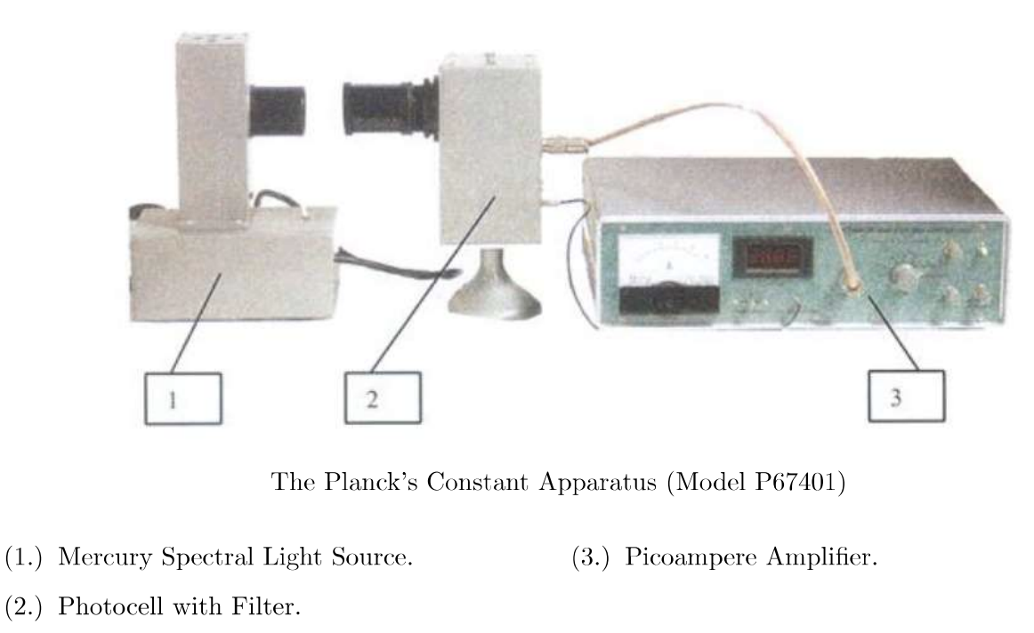

Figure - The experimental setup

The filters that were used in the experiment include the 365.0nm, 404.7nm, 435.8nm, 546.1nm, and 577.0nm. To set up the experiment, the circuit seen in Figure 2 was followed. The positioning of the devices can be lined up by hand so that the light source is pointing directly at the photocell with filter.

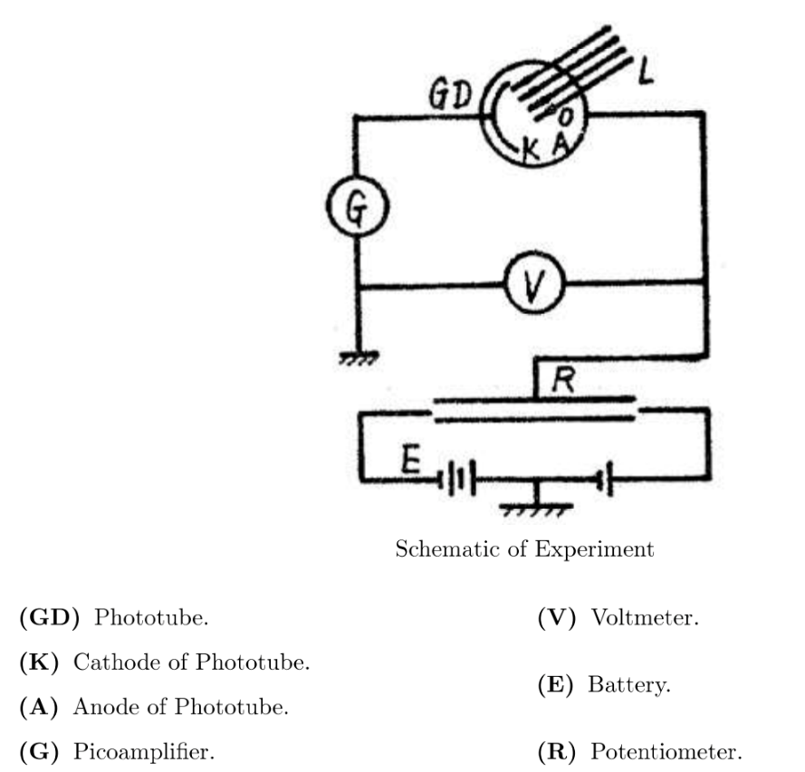

Using this set up, measurements for the current and voltages were able to be recorded for each filter. The voltage of the input to the system was varied at steps of 0.1V until 2V where the experiment for each filter was completed. The system was not calibrated, but the dark current was used to set the baseline that was used to interpret each filter stopping voltage.

# Results and Analysis

Before an analysis could begin, data needed to be obtained on the Dark Current and various wavelength filters. Below are the recorded data of those values with the first column being the current in Amperes, and the Voltage applied in volts.

## Experimental Data

### Dark Current

|  |  |
| --- | --- |
| Current (A) | Voltage (V) |
| 2.5±0.5 e-12 | 0± 0.002 |
| 2.5±0.5 e-12 | -.1± 0.002 |
| 2.5±0.5 e-12 | -.2± 0.002 |
| 2.5±0.5 e-12 | -.3± 0.002 |
| 2.5±0.5 e-12 | -.4± 0.002 |
| 2.5±0.5 e-12 | -.5± 0.002 |
| 2.5±0.5 e-12 | -.6± 0.002 |
| 2.5±0.5 e-12 | -.7± 0.002 |
| 2.5±0.5 e-12 | -.8± 0.002 |
| 2.5±0.5 e-12 | -.9± 0.002 |
| 2.5±0.5 e-12 | -1.0± 0.002 |
| 2.5±0.5 e-12 | -1.1± 0.002 |
| 2.5±0.5 e-12 | -1.2± 0.002 |
| 2.5±0.5 e-12 | -1.3± 0.002 |
| 2.5±0.5 e-12 | -1.4± 0.002 |
| 2.5±0.5 e-12 | -1.5± 0.002 |
| 2.5±0.5 e-12 | -1.6± 0.002 |
| 2.5±0.5 e-12 | -1.7± 0.002 |
| 2.5±0.5 e-12 | -1.8± 0.002 |
| 2.5±0.5 e-12 | -1.9± 0.002 |
| 2.5±0.5 e-12 | -2.0± 0.002 |

### Filter: 365.0nm

|  |  |
| --- | --- |
| Current (A) | Voltage (V) |
| 82 e-10 | 0± 0.002 |
| 72 e-10 | -.1± 0.002 |
| 64 e-10 | -.2± 0.002 |
| 58.5 e-10 | -.3± 0.002 |
| 50 e-10 | -.4± 0.002 |
| 43 e-10 | -.5± 0.002 |
| 38 e-10 | -.6± 0.002 |
| 30 e-10 | -.7± 0.002 |
| 24 e-10 | -.8± 0.002 |
| 18 e-10 | -.9± 0.002 |
| 13 e-10 | -1.0± 0.002 |
| 8 e-10 | -1.1± 0.002 |
| 4 e-10 | -1.2± 0.002 |
| 60 e-11 | -1.3± 0.002 |
| 33 e-11 | -1.4± 0.002 |
| 13 e-11 | -1.5± 0.002 |
| 60 e-12 | -1.6± 0.002 |
| 0 | -1.7± 0.002 |
| 0 | -1.8± 0.002 |
| 0 | -1.9± 0.002 |

### Filter: 404.7nm

|  |  |
| --- | --- |
| Current (A) | Voltage (V) |
| 73 e-11 | 0± 0.002 |
| 63 e-11 | -.1± 0.002 |
| 53 e-11 | -.2± 0.002 |
| 43 e-11 | -.3± 0.002 |
| 37 e-11 | -.4± 0.002 |
| 29 e-11 | -.5± 0.002 |
| 21 e-11 | -.6± 0.002 |
| 15 e-11 | -.7± 0.002 |
| 9 e-11 | -.8± 0.002 |
| 4 e-11 | -.9± 0.002 |
| 51 e-12 | -1.0± 0.002 |
| 22 e-12 | -1.1± 0.002 |
| 4 e-12 | -1.2± 0.002 |
| -7 e-12 | -1.3± 0.002 |
| -12 e-12 | -1.4± 0.002 |
| -14 e-12 | -1.5± 0.002 |
| -15 e-12 | -1.6± 0.002 |
| -16 e-12 | -1.7± 0.002 |
| -16 e-12 | -1.8± 0.002 |
| -16 e-12 | -1.9± 0.002 |
| -16 e-12 | -2.0± 0.002 |

### Filter: 435.8nm

|  |  |
| --- | --- |
| Current (A) | Voltage (V) |
| 35 e-10 | 0± 0.002 |
| 33 e-10 | -.1± 0.002 |
| 31.5 e-10 | -.2± 0.002 |
| 29.5 e-10 | -.3± 0.002 |
| 27.5 e-10 | -.4± 0.002 |
| 25.5 e-10 | -.5± 0.002 |
| 23.5 e-10 | -.6± 0.002 |
| 21 e-10 | -.7± 0.002 |
| 19.5 e-10 | -.8± 0.002 |
| 17 e-10 | -.9± 0.002 |
| 15 e-10 | -1.0± 0.002 |
| 13.5 e-10 | -1.1± 0.002 |
| 12 e-10 | -1.2± 0.002 |
| 10.5 e-10 | -1.3± 0.002 |
| 9 e-10 | -1.4± 0.002 |
| 7 e-1o | -1.5± 0.002 |
| 5 e-10 | -1.6± 0.002 |
| 3.3 e-10 | -1.7± 0.002 |
| 2.1 e-10 | -1.8± 0.002 |
| 1 e-10 | -1.9± 0.002 |
| 0 | -2.0± 0.002 |

### Filter: 546.1nm

|  |  |
| --- | --- |
| Current (A) | Voltage (V) |
| 26 e-11 | 0± 0.002 |
| 20 e-11 | -.1± 0.002 |
| 12 e-11 | -.2± 0.002 |
| 5 e-11 | -.3± 0.002 |
| 27.5 e-12 | -.4± 0.002 |
| 44 e-12 | -.5± 0.002 |
| 8 e-12 | -.6± 0.002 |
| -12 e-12 | -.7± 0.002 |
| -17 e-12 | -.8± 0.002 |
| -18 e-12 | -.9± 0.002 |
| -18 e-12 | -1.0± 0.002 |
| -18 e-12 | -1.1± 0.002 |
| -18 e-12 | -1.2± 0.002 |
| -18 e-12 | -1.3± 0.002 |
| -18 e-12 | -1.4± 0.002 |
| -18 e-12 | -1.5± 0.002 |
| -18 e-12 | -1.6± 0.002 |
| -18 e-12 | -1.7± 0.002 |
| -18 e-12 | -1.8± 0.002 |
| -18 e-12 | -1.9± 0.002 |
| -18 e-12 | -2.0± 0.002 |

### Filter: 577.0nm

|  |  |
| --- | --- |
| Current (A) | Voltage (V) |
| 49 e-4 | 0± 0.002 |
| 33 e-4 | -.1± 0.002 |
| 20 e-4 | -.2± 0.002 |
| 10 e-4 | -.3± 0.002 |
| 2 e-4 | -.4± 0.002 |
| 2 e-4 | -.5± 0.002 |
| 2 e-4 | -.6± 0.002 |
| 2 e-4 | -.7± 0.002 |
| 2 e-4 | -.8± 0.002 |
| 2 e-4 | -.9± 0.002 |
| 2 e-4 | -1.0± 0.002 |
| 2 e-4 | -1.1± 0.002 |
| 2 e-4 | -1.2± 0.002 |
| 2 e-4 | -1.3± 0.002 |
| 2 e-4 | -1.4± 0.002 |
| 2 e-4 | -1.5± 0.002 |
| 2 e-4 | -1.6± 0.002 |
| 2 e-4 | -1.7± 0.002 |
| 2 e-4 | -1.8± 0.002 |
| 2 e-4 | -1.9± 0.002 |
| 2 e-4 | -2.0± 0.002 |

## Filter Graphs with Stopping Potential

The dark current measured was plotted against each of the filters with the goal to find the intersection point which represent the stopping potential in volts of each filter used. The following graphs show each of the filters with a circle point dictating the intersection point between each of the curves. The stopping potential is the voltage required to reach the same current in the ammeter as what was read during the dark current measurements when no light source was used.

It is obvious from the last graph that the 435nm filter reported values that do not follow the trend of the other lines, yielding strange values for the rest of the analysis and report. It would be beneficial to verify these values if the test can be done again. The overall trend tends to show that as the filter wavelength increases, the stopping potential calculated from the intersection of the recorded data lines tends to decrease. It ranges from -1.4V with the smallest wavelength filter to -0.4V with the biggest. The 435nm filter exhibited a much larger stopping potential with -2.0 volts. The table below details the values in a clearer format with the wavelength measured in nanometers and the stopping potential in volts.

|  |  |
| --- | --- |
| Wavelength (nm) | Stopping Potential (V) |
| 365 | -1.4 |
| 404 | -1.0 |
| 435 | -2.0 |
| 546 | -0.5 |
| 577 | -0.4 |

## Determining Plank’s Constant

The fundamental constant, Plank’s Constant, can be calculated from the fundamental equation

$$h=e*SP /f$$

where h is Plank’s Constant, e is the charge of an electron, SP is the stopping potential, and f is the frequency as related to the filter’s wavelength. The figure below shows a graph of the data of stopping potential vs. frequency for each filter tested. The uncertainties were calculated for each stopping potential from analyzing the uncertainty with the physical measurements used during experimentation and the ammeter uncertainty. A fitting curve was also used to find a line of best fit that matches the experimental data and be used to predict the stopping potential at any frequency.

Those values can then be plugged into the Plank equation to determine the estimated constant of each filter. They were then averaged, and the result is shown below in the table against the NIST standard value of Plank’s constant.

|  |  |
| --- | --- |
|  | Planks Constant ( $m^{2}kg/s)$ |
| Experimental | $$2.5*{10}^{-35}±7.8*{10}^{-35}$$ |
| Actual | $$6.6*{10}^{-34}$$ |

With the error described above, even with the error bars, it is not within the current NIST standard of the true value. This was determined by calculating the upper and lower bound of the experimental results and noting if the actual Plank’s constant is within that bound. The experimental and actual values have a difference of 1.8% using the basic difference equation comparing the two overall values of actual and experimental constants. This falls around an order of magnitude of difference between the assumed actual constant and the experimental constant calculated.

## Work Function Determination and Exit Velocity

The work function of the material is estimated to be $8.3*{10}^{-20}$ J with an error of $1.6*{10}^{-19}$ J. The work function value means the energy needed to extract one electron from the material. This was determined using the equation

$$Work Function= hc/λ$$

Where h is the experimental Plank’s constant, c is the speed of light, and $λ$ is the wavelength of each filter used in the experiment. The values were averaged to obtain the overall value to be reported. With the work function calculated for each filter, the maximum escape velocity of the electron leaving the material is given as

$$v= \sqrt{\frac{hf-Work Function}{0.5* m_{e}}}$$

where $m_{e}$ is the mass of an electron which is known. The values for each filter are listed below. It is obvious that as the filter increases its wavelength, a greater maximum escape velocity is calculated.

|  |  |
| --- | --- |
| Wavelength (nm) | Maximum Escape Velocity (10^5 m/s) |
| 365 | 5.1 |
| 404 | 4.7 |
| 435 | 4.4 |
| 546 | 3.4 |
| 577 | 3.2 |

## Re-design Considerations

The largest contribution to the uncertainty in our measurements, and in turn, our analysis of core parameters, is due to the experimental setup and equipment used. The equipment positioning was done by eye and not bolted down, leading to variation from filter to filter measurements. The ammeter also was old and not calibrated, meaning it could yield much different values then what would be recorded from a newer, calibrated model. All of this contributes to the overall uncertainty, and by fixing these, we would get closer to the NIST standard as they used the top equipment the world has to offer with repeatable experiments.

## General Data Presentation

Tables and plots, both used within this report, are the primary way to display data as it allows the reader to understand the full picture of the experiment in a clean and organized matter. It is important for the researcher or scientists to make the plot clean and clear so all the information meant for the reader can be reasoned easily.

# Conclusions

Through experimental measurement and graphing, an estimation for Planck’s constant was able to be found and used to find the escape velocity for the electrons in each filter. After setting up the lab, a series of measurements were able to be taken for the 6 filters. Using these measured values, a program was able to be made to find and graph the wavelength and stopping potential of each filter. Using the graph, Planck’s constant was able to be estimated with some error. This helped in the understanding of the photoelectric effect and the understanding of where Planck’s constant comes from. Through this the work function was used to find the exit velocity.

There were multiple factors within the entire experiment that caused variation from the true result we were looking for. The first one was the machines being used: each were old and not calibrate before us causing error within its measurement for current. The second was the difference in how the experiment was run from filter to filter as different people conducted each reading of the different filters. The last source of variation was the overall physical experimental setup, that could have physically varied through each measurement from not being fixed to the experimental table within the lab.

# Reference

“Photoelectric Effect.” *Photoelectric Effect*, ch301.cm.utexas.edu/section2.php?target=atomic%2FEM%2Fphotoelectric.html.

Elert, Glenn. “Photoelectric Effect.” *The Physics Hypertextbook*, physics.info/photoelectric/.

# Appendix

## Code

The analysis was done via MATLAB as the tools within that program was more accessible to the members of the experimental group. Below is the appended code used to calculate the results within the report above. Some calculations were done by hand outside of the program.

clear all; close all;

% Filters

Voltage = [0,-.1,-.2,-.3,-.4,-.5,-.6,-.7,-.8,-.9,-1,-1.1,-1.2,-1.3,-1.4,-1.5,-1.6,-1.7,-1.8,-1.9,-2];

DarkCurrent = [0,0,0,0,0,0,0,0,0,0,0,0,0,0,0,0,0,0,0,0,0];

Current577 = [49,33,20,10,2,0,0,0,0,0,0,0,0,0,0,0,0,0,0,0,0].*10^-11;

Current435 = [35,33,31.5,29.5,27.5,25.5,23.5,21,19.5,17,15,13.5,12,10.5,9,7,5,3.3,2.1,1,0]*10^-10;

Current365 = [82,72,64,58,50,43,38,30,24,18,13,8,4,.6,.33,.13,.06,0,0,0,0]*10^-10;

Current546 = [26,20,12,5,.84,.08,.012,.008,.008,.008,.008,.008,.008,.008,.008,.008,.008,.008,.008,.008,.008]*10^-10;

Current404 = [73,63,53,43,37,29,21,15,9,4,.51,.22,.11,-.7,-.12,-.14,-.15,-.16,-.16,-.16,-.16]*10^-10;

f1=figure(1);

plot(Voltage,Current365)

hold on

plot(Voltage,DarkCurrent)

plot(-1.4,0,'o')

xlabel('Voltage (V)')

ylabel('Current (A)')

title('365nm Filter and Dark Current Intersection')

legend('365nm','Dark Current')

f2=figure(2);

plot(Voltage,Current404)

hold on

plot(Voltage,DarkCurrent)

plot(-1,0,'o')

xlabel('Voltage (V)')

ylabel('Current (A)')

title('404nm Filter and Dark Current Intersection')

legend('404nm','Dark Current')

f3=figure(3);

plot(Voltage,Current435)

hold on

plot(Voltage,DarkCurrent)

plot(-2,0,'o')

xlabel('Voltage (V)')

ylabel('Current (A)')

title('435nm Filter and Dark Current Intersection')

legend('435nm','Dark Current')

f4=figure(4);

plot(Voltage,Current546)

hold on

plot(Voltage,DarkCurrent)

plot(-0.5,0,'o')

xlabel('Voltage (V)')

ylabel('Current (A)')

title('546nm Filter and Dark Current Intersection')

legend('546nm','Dark Current')

f5=figure(5);

plot(Voltage,Current577)

hold on

plot(Voltage,DarkCurrent)

plot(-0.5,0,'o')

xlabel('Voltage (V)')

ylabel('Current (A)')

title('577nm Filter and Dark Current Intersection')

legend('577nm','Dark Current')

f6=figure(6);

plot(Voltage,Current365)

hold on

plot(Voltage,Current404)

plot(Voltage,Current435)

plot(Voltage,Current546)

plot(Voltage,Current577)

xlabel('Voltage (V)')

ylabel('Current (A)')

title('All Filters plotted with the Dark Current')

legend('365nm','404nm','435nm','546nm','577nm','location','northwest')

saveas(f1,'365nm.png')

saveas(f2,'404nm.png')

saveas(f3,'435nm.png')

saveas(f4,'546nm.png')

saveas(f5,'577nm.png')

saveas(f6,'allnm.png')

Problem 3

StoppingPot = [-1.4,-1.0,-2.0,-.5,-.5];

c = 2.99*10^9;

Wavelength = [365,404,435,546,577]*10^-9;

Frequency = c./Wavelength;

f7 = figure(7);

err = .1*ones(size(Frequency));

errorbar(Frequency,StoppingPot,err)

title('Affect of Frequency on Stopping Potential')

xlabel('Frequency (Hz)')

ylabel('Stopping Potential (V)')

saveas(f7,'stoppingpotvsfreq.png')

hact = 6.626*10^-34

e = 1.602*10^-19;

h = -(e*StoppingPot)./Frequency;

havg = mean(h)

errh = 7.8*10^-35

Problem 4

upperbound = havg+errh

percentdiff = (hact-havg)/((hact+havg)/2)

Problem 5

workfunction = ((havg*c)./Wavelength)/2

workfunction = mean(workfunction)

errworkfunction = 2*workfunction

me = 9.1*10^-31

v = sqrt((havg.*Frequency-workfunction)/(.5*me))